Theme IS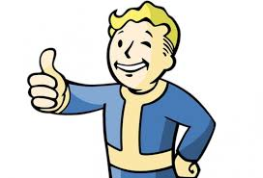 | Theme IS NOT
- Universal; the author’s hidden message about human life OR  - A statement about the author’s message regarding his/her topic.  - Associated with the author’s main point/purpose for writing. (Think about what the author would say about Topic X if s/he were sitting next to you).  - Inferred: you the reader must look for clues!  - Is a DECLARATIVE SENTENCE! | - A single word a.k.a ‘Love’  - A moral/lesson  - A command  - A cliché  - An “if/then” statement  - A “you” statement  - An infinitive (to + a verb)  - Wordy to the point of being unclear

