Advanced Placement Exams (AP) Resources on UDLib/SEARCH
Go to: http://udlibsearch.lib.udel.edu/highschools/
Click on Test Prep then underneath click on Testing & Education Resource Center. See screen shot below:
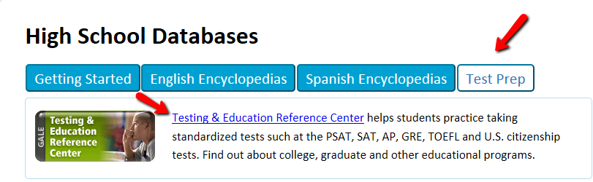
From home it will ask for your username and password.
Username: udlibsearch
Password: homeaccess
Then click on High School Tools at the top or bottom of the page. You can access AP Exams Prep materials (online books, and online practice tests). To access the materials the first time you will need to register as a new user and set up your free account. See screen shot below:
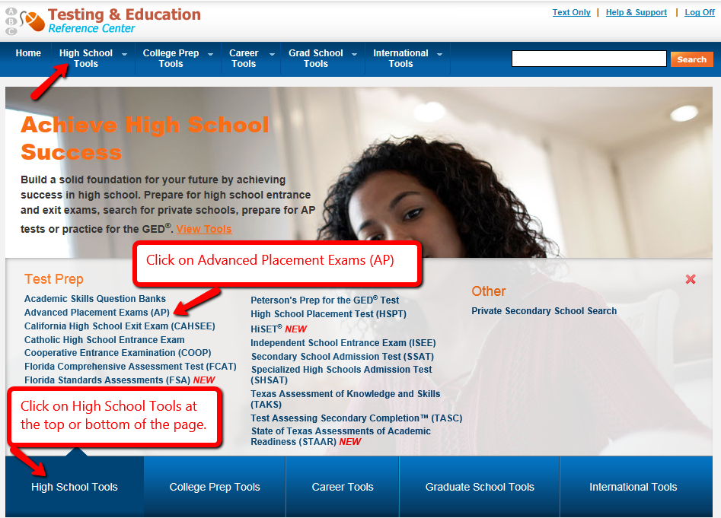

There are resources for the following Advanced Placement Exams (AP):
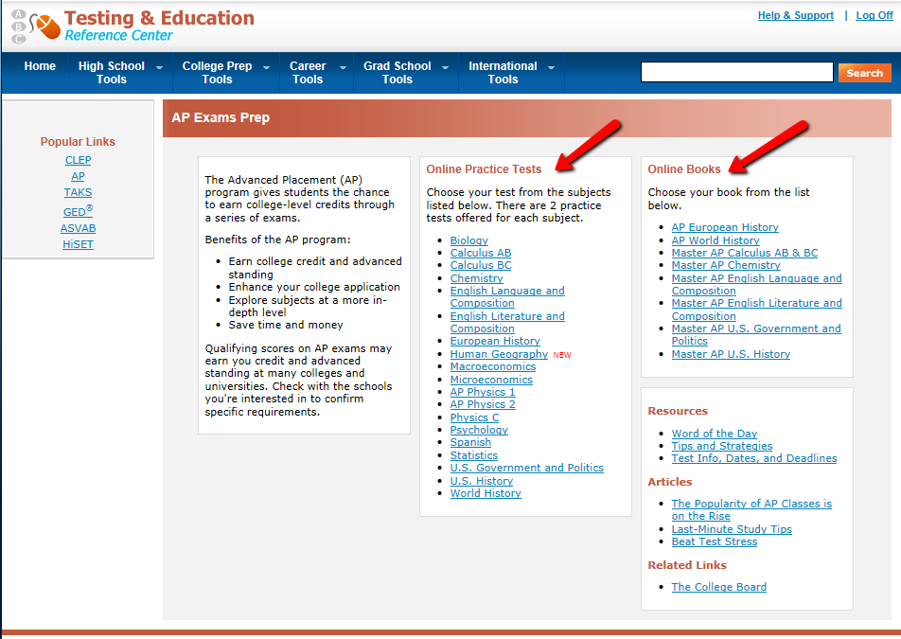

Created by Janis McKnight March 7, 2017

